Statement Coverage Testing

Statement coverage is one of the widely used software testing. It comes under white box testing.

Statement coverage technique is used to design white box test cases. This technique involves execution of all statements of the source code at least once. It is used to calculate the total number of executed statements in the source code out of total statements present in the source code.

Statement coverage derives scenario of test cases under the white box testing process which is based upon the structure of the code.

Statement Coverage  

In white box testing, concentration of the tester is on the working of internal source code and flow chart or flow graph of the code.

Generally, in the internal source code, there is a wide variety of elements like operators, methods, arrays, looping, control statements, exception handlers, etc. Based on the input given to the program, some code statements are executed and some may not be executed. The goal of statement coverage technique is to cover all the possible executing statements and path lines in the code.

Let's understand the process of calculating statement coverage by an example:

Here, we are taking source code to create two different scenarios according to input values to check the percentage of statement coverage for each scenario.

**Source Code:**

Prints (int a, int b) { ------------ Printsum is a function

int result = a+ b;

If (result> 0)

Print ("Positive", result)

Else

Print ("Negative", result)

}

**Scenario 1:**

If A = 3, B = 9

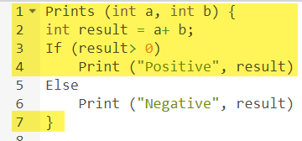

The statements marked in yellow color are those which are executed as per the scenario

Number of executed statements = 5, Total number of statements = 7

Statement Coverage: 5/7 = 71%

Likewise we will see scenario 2,

**Scenario 2:**

If A = -3, B = -9

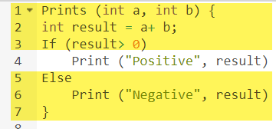

The statements marked in yellow color are those which are executed as per the scenario.

Number of executed statements = 6

Total number of statements = 7

[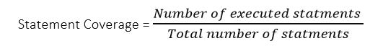](https://www.guru99.com/images/jsp/030116_0814_LearnStatem6.png)

Statement Coverage: 6/7 = 85%

**What is covered by Statement Coverage?**

1. Unused Statements
2. Dead Code
3. Unused Branches